Student’s name Teacher’s name

________________________________________ _____________________________



2016
Mathematics 5.2
End Semester 2 Examination

General Instructions  - Reading time – 5 minutes  - Working time –45 minutes  - Write using blue or black pen  Black pen is preferred  - Scientific calculators may be used | Total Marks – 54  - Questions arranged in topics. Attempt questions from all topics.

Section | 1 | 2 | 3 | Total
 | $$\frac{}{18}$$ | $$\frac{}{18}$$ | $$\frac{}{18}$$

Student Comment:

Teacher Comment:
<Surface Area and Volume>
<18> marks
Attempt all Questions
Questions <1 to 4> Multiple choice
Allow about 15 minutes for this section

Circle the correct answer for Questions <1 to 4>

1. | If the area of a square field is 64km² the length of one side could be
 | (A) 8km |  | (B) 6km | (C) 4km | (D) 16km
2. | The perimeter of this shape is:  1m  3m
 | (A) 8m |  | (B) 16m | (C) 15m | (D) 13m
3. | The surface area of this rectangular prism is:  5m  3m  7m
 | (A) 130m² |  | (B) 15m² | (C) 71m² | (D) 142m²
4. | The volume of a cylinder with a radius 3cm and a height of 10cm is closest to:
 | (A) 270cm² |  | (B) 90cm² | (C) 60cm² | (D) 30cm²
Questions <5-7> Short Answer. Show all working. Marks are as shown

5.
 |  |  |  |  |  |  | Marks
 | a. | 15cm = _____mm |  |  |  |  | 1
 | b. | 5 days = _______hours |  |  |  |  | 1
 | c. | 6 years = ________days  (not a leap year) |  |  |  |  | 1
6. | A teacher collects some blocks of wood for a classroom activity. Each block is a rectangular prism as shown.  7cm  8cm  18cm
 |  |  |  |  |  |  | Marks
 | a. | Find the volume of the block. |  |  |  |  | 2
 | b. | The block is to be painted on all sides. Find the total outside to be painted for each block in cm². |  |  |  |  | 2
 | c. | Paint costs $5.50 per 100cm². Find the cost of painting 12 blocks. |  |  |  |  | 2
 | d. | Another block is a cylinder with a radius of 7cm and height of 17cm. Compared to the rectangular block does it have a greater volume or surface area? |  |  |  |  | 2
7.
 |  |  |  |  |  | Marks
 | How many litres of gas can a tanker carry if its tank is cylindrical with a diameter of 2.2m and is 14m in length? Round your answer to the nearest L. (1m³ = 1000L) |  |  |  |  | 3

<Indices>
<18> marks
Attempt all Questions
Questions <8 to 11> Multiple choice
Allow about 15 minutes for this section

Circle the correct answer for Questions <8 to 11>

8. | 6a⁵ × 6a² =
 | (A) 12a¹⁰ |  | (B) 12a⁷ | (C) 11a¹⁰ | (D) 36a⁷
9. | 5(7m³)⁰
 | (A) 5 |  | (B) 12 | (C) 35m³ | (D) 0
10. | (2a³)²
 | (A) 4a⁶ |  | (B) 4a⁵ | (C) 2a⁶ | (D) 2a³²
11. | The mass of a shipping container is 5.33 × 10³ kg. In expanded form this mass in kilograms is:
 | (A) 533000kg |  | (B) 5330kg | (C) 533kg | (D) 0.00533kg
Questions <12-14> Short Answer. Show all working. Marks are as shown

12.
 |  |  |  |  |  |  | Marks
 | a. | x⁵ × x⁴ = |  |  |  |  | 1
 | b. | x¹⁴ × x⁸ = |  |  |  |  | 1
 | c. | (m⁴)⁶ = |  |  |  |  | 1
13.
 |  |  |  |  |  |  | Marks
 | a. | 3a⁴ b³ × 7ab = |  |  |  |  | 2
 | b. | x⁹y⁷ ÷ (x³ y)² = |  |  |  |  | 2
 | c. | $\frac{8a^{9}b^{6}}{16a^{4}b}$ = |  |  |  |  | 2
 | d. | (2a⁵)⁶ = |  |  |  |  | 2
14.
 |  |  |  |  |  | Marks
 | Write the following in scientific notation in the units given to 3 significant figures.  2 years in hours. |  |  |  |  | 3

<Properties of Geometrical Figures>
<18> marks
Attempt all Questions
Questions <15 to 18> Multiple choice
Allow about 15 minutes for this section

Circle the correct answer for Questions <15 to 18>

15. | 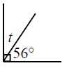
 | (A) t = 34 |  | (B) t = 90 | (C) t= 24 | (D) t = 36
16. | 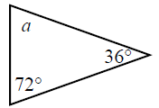
 | (A) a = 90 |  | (B) a = 180 | (C) a = 72 | (D) a = 108
17. | 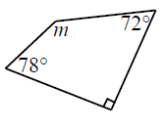
 | (A) m = 160 |  | (B) m = 210 | (C) m = 120 | (D) m = 130
18. | What is the name of this 4 sided shape?
 | (A) square |  | (B) rhombus | (C) rectangle | (D) trapezium
Questions <19-21> Short Answer. Show all working. Marks are as shown

19. | 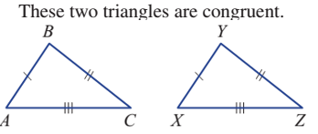
 |  |  |  |  |  |  | Marks
 | a. | Name the side on triangle XYZ that matches the side BC. |  |  |  |  | 1
 | b. | Name the angle in the triangle ABC that matches angle Y. |  |  |  |  | 1
 | c. | Which 2 triangles are congruent? 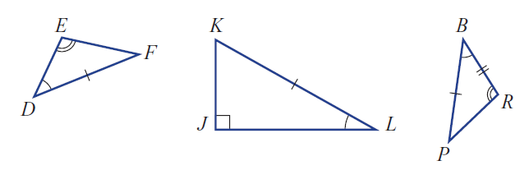 |  |  |  |  | 1
20.
 |  |  |  |  |  |  | Marks
 | a. | Find the values of the pronumerals in this pair of congruent triangles.  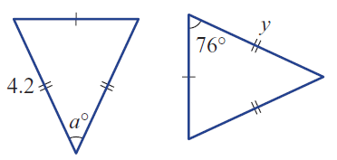 |  |  |  |  | 2
 | b. | Find a and b.  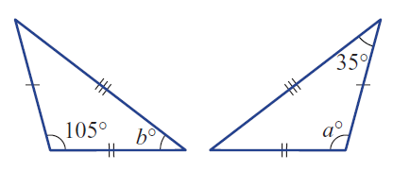 |  |  |  |  | 2
 | c. | 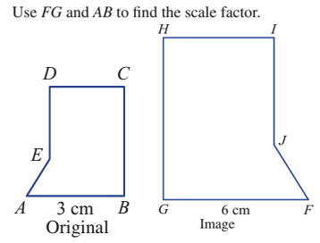  A 7cm B G 21cm F |  |  |  |  | 2
 | d. | Find y and x.  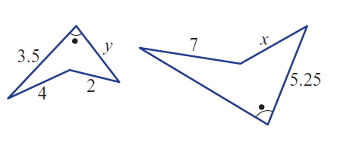 |  |  |  |  | 2
21.
 |  |  |  |  |  | Marks
 | 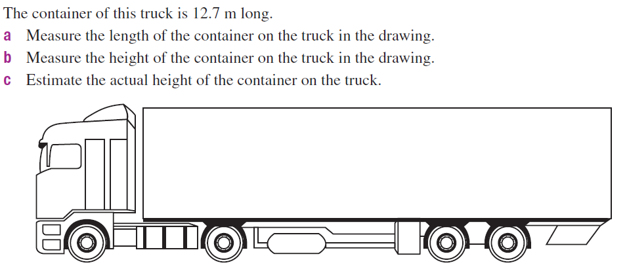 |  |  |  |  | 3

END OF EXAM

